DAY 1
Q1: Write a program to input two numbers and display their sum.

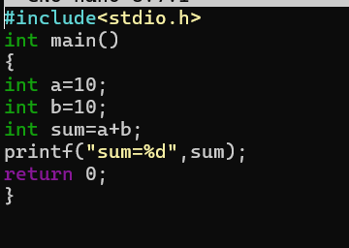
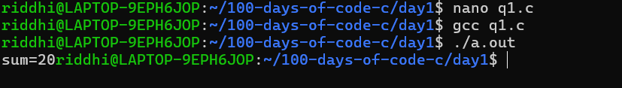

Q2: Write a program to input two numbers and display their sum, difference, product, and quotient.
